## String Operations

**Description**

A module which contains some Java action like palindrome check, swapping string, reverse a string and replace one word into another word.

**Typical Usage Scenario**

If you are developing an application that allows users to perform various manipulations on input text. The typical usage scenario could involve a user inputting a sentence or phrase into the application. Then you can import this module

**PreRequisites**

NA

**Features and Limitations**

Palindrome: In the palindrome check module, users input a word or phrase, and the system validates and processes the input to determine if it reads the same forward and backward. The result of the palindrome check is then provided to the user.

String Swapping: If the user selects this option, they can specify two indices in the input sentence where they want to swap the characters. The java action performs the swap and presents the modified sentence.

Word Replacement: Choosing this option allows the user to provide a target word and the word they want to replace it with. The module scans the input sentence and replaces all occurrences of the target word with the replacement word, displaying the updated sentence.

String Reverse: The user can choose to reverse the entire input sentence. The java action will display the reversed sentence.

**Dependencies**

Requires Mendix 9.1.1 or above

**Installation**

1. Download the package from marketplace.
2. Import the module package into your project.
3. Configure security of application by providing access for respective module roles.
4. Call the Java Action

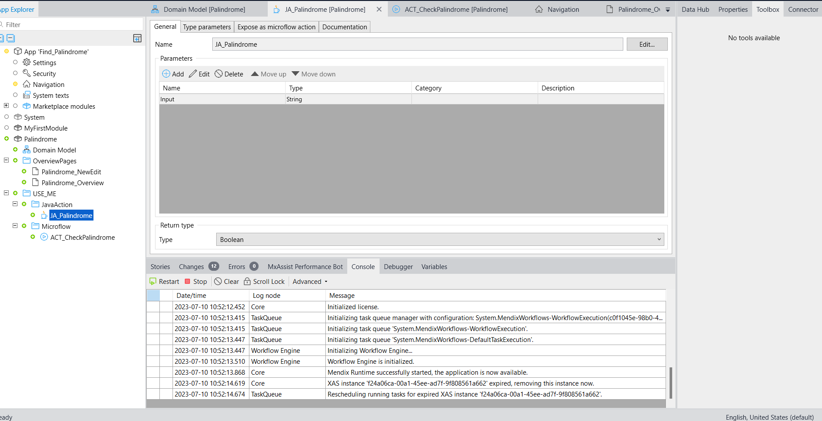

**Configuration: NA**

**Category: Module**

**Subcategory: All**

**Visibility: Public Marketplace**

**Studio Pro Version: 9.1.1**